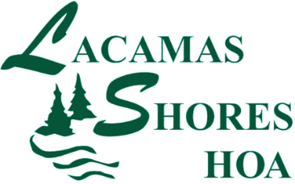

Working Board Meeting Agenda
Monday, June 19, 2017
Meadowlands Picnic Area at 7:00 pm
- Roll Call of Board Members and confirmation of quorum
- Proof of Notice
- Old Business
  - Maintenance Update
  - Amended Tree Policy discussion
    - Member Comment
    - Board Discussion
    - Fines and Fees Policy- as relates to the Tree Policy
    - Board Summation – Wrap up And Action item
- New Business
  - July 4th Celebration - Status
- Adjournment

